1-Local Email
# Source: AI Source: Provided by: [Data Path: Persons Table -> ID Column: 1, Name_En Column: Motasem Essam] -> From: [ChatGPT] on [1/21/2026]
Local Email refers to an email system that is hosted and managed on your own computer or local server, rather than using an external cloud provider like Gmail or Outlook.

💡 What Is Local Email?
# Source: AI Source: Provided by: [Data Path: Persons Table -> ID Column: 1, Name_En Column: Motasem Essam] -> From: [ChatGPT] on [1/21/2026]
A local email setup means:
- You control the email server (MTA like Postfix or Exim)
- You store emails on your own disk (in local mailboxes or Maildirs)
- Users access emails via IMAP, POP3, or directly as files
- Used for intranet, testing, or privacy-focused environments

🧱 Components of Local Email
# Source: AI Source: Provided by: [Data Path: Persons Table -> ID Column: 1, Name_En Column: Motasem Essam] -> From: [ChatGPT] on [1/21/2026]
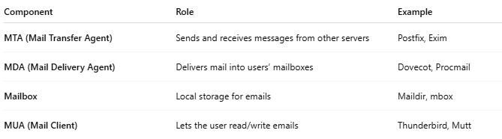

Component | Role | Example
MTA (Mail Transfer Agent) | Sends and receives messages from other servers | Postfix, Exim
MDA (Mail Delivery Agent) | Delivers mail into users’ mailboxes | Dovecot, Procmail
Mailbox | Local storage for emails | Maildir, mbox
MUA (Mail Client) | Lets the user read/write emails | Thunderbird, Mutt

🔁 Local Email Flow
# Source: AI Source: Provided by: [Data Path: Persons Table -> ID Column: 1, Name_En Column: Motasem Essam] -> From: [ChatGPT] on [1/21/2026]
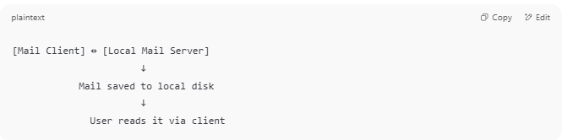

[Mail Client] ↔ [Local Mail Server]
↓
Mail saved to local disk
↓
User reads it via client

📥 Example: Simple Local Delivery (Linux)
# Source: AI Source: Provided by: [Data Path: Persons Table -> ID Column: 1, Name_En Column: Motasem Essam] -> From: [ChatGPT] on [1/21/2026]
You can send a message from user A to user B:
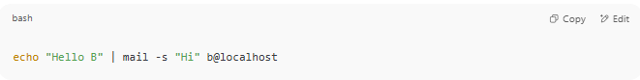
echo "Hello B" | mail -s "Hi" b@localhost

This delivers directly to b’s local mailbox.

⚖️ Local Email vs Cloud Email
# Source: AI Source: Provided by: [Data Path: Persons Table -> ID Column: 1, Name_En Column: Motasem Essam] -> From: [ChatGPT] on [1/21/2026]
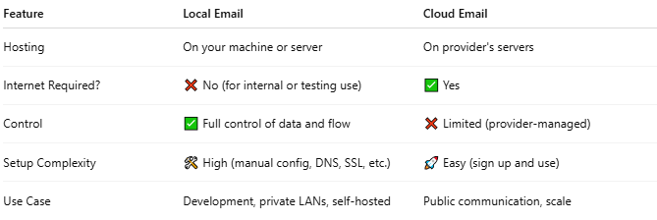

Feature | Local Email | Cloud Email
Hosting | On your machine or server | On provider's servers
Internet Required? | ❌ No (for internal or testing use) | ✅ Yes
Control | ✅ Full control of data and flow | ❌ Limited (provider-managed)
Setup Complexity | 🛠 High (manual config, DNS, SSL, etc.) | 🚀 Easy (sign up and use)
Use Case | Development, private LANs, self-hosted | Public communication, scale

✅ When to Use Local Email
# Source: AI Source: Provided by: [Data Path: Persons Table -> ID Column: 1, Name_En Column: Motasem Essam] -> From: [ChatGPT] on [1/21/2026]
- 📶 Offline/local networks (internal business tools)
- 🧪 Testing/dev environments (e.g. MailHog, Mailtrap simulate this)
- 🔐 Security-conscious setups (data never leaves your server)
- 🧰 Learning email infrastructure (Postfix + Dovecot training)

⚠️ Drawbacks of Local Email
# Source: AI Source: Provided by: [Data Path: Persons Table -> ID Column: 1, Name_En Column: Motasem Essam] -> From: [ChatGPT] on [1/21/2026]
- Harder to configure (DNS, SPF, DKIM)
- Spam detection is manual
- Deliverability is limited (may get blocked by Gmail/Yahoo)
- Requires server uptime and security maintenance

✅ Summary
# Source: AI Source: Provided by: [Data Path: Persons Table -> ID Column: 1, Name_En Column: Motasem Essam] -> From: [ChatGPT] on [1/21/2026]
Local Email means running your own email server and storing messages on your computer or private server — no cloud, no third-party provider.
It’s powerful, private, and flexible — but not easy for beginners.

2-Cloud Email
# Source: AI Source: Provided by: [Data Path: Persons Table -> ID Column: 1, Name_En Column: Motasem Essam] -> From: [ChatGPT] on [1/21/2026]
Cloud Email refers to email services that are hosted and managed by third-party providers on the internet, instead of running on your own physical server. Examples include Gmail, Outlook.com, Yahoo Mail, and Zoho Mail.

☁️ What Is Cloud Email?
# Source: AI Source: Provided by: [Data Path: Persons Table -> ID Column: 1, Name_En Column: Motasem Essam] -> From: [ChatGPT] on [1/21/2026]
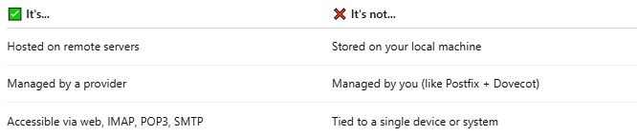

✅ It's... | ❌ It's not...
Hosted on remote servers | Stored on your local machine
Managed by a provider | Managed by you (like Postfix + Dovecot)
Accessible via web, IMAP, POP3, SMTP | Tied to a single device or system

📦 Key Features
# Source: AI Source: Provided by: [Data Path: Persons Table -> ID Column: 1, Name_En Column: Motasem Essam] -> From: [ChatGPT] on [1/21/2026]
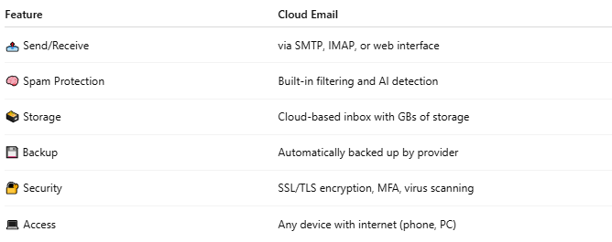

Feature | Cloud Email
📤 Send/Receive | via SMTP, IMAP, or web interface
🧠 Spam Protection | Built-in filtering and AI detection
🗃 Storage | Cloud-based inbox with GBs of storage
💾 Backup | Automatically backed up by provider
🔐 Security | SSL/TLS encryption, MFA, virus scanning
💻 Access | Any device with internet (phone, PC)

🌍 Popular Cloud Email Providers
# Source: AI Source: Provided by: [Data Path: Persons Table -> ID Column: 1, Name_En Column: Motasem Essam] -> From: [ChatGPT] on [1/21/2026]
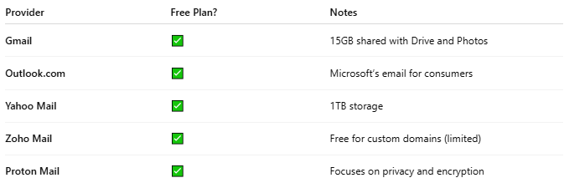

Provider | Free Plan? | Notes
Gmail | ✅ | 15GB shared with Drive and Photos
Outlook.com | ✅ | Microsoft’s email for consumers
Yahoo Mail | ✅ | 1TB storage
Zoho Mail | ✅ | Free for custom domains (limited)
Proton Mail | ✅ | Focuses on privacy and encryption

🧠 Cloud Email vs Local Email
# Source: AI Source: Provided by: [Data Path: Persons Table -> ID Column: 1, Name_En Column: Motasem Essam] -> From: [ChatGPT] on [1/21/2026]
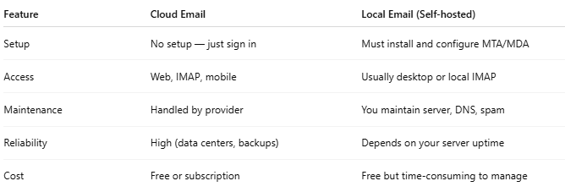
Feature | Cloud Email | Local Email (Self-hosted)
Setup | No setup — just sign in | Must install and configure MTA/MDA
Access | Web, IMAP, mobile | Usually desktop or local IMAP
Maintenance | Handled by provider | You maintain server, DNS, spam
Reliability | High (data centers, backups) | Depends on your server uptime
Cost | Free or subscription | Free but time-consuming to manage

📌 Summary
# Source: AI Source: Provided by: [Data Path: Persons Table -> ID Column: 1, Name_En Column: Motasem Essam] -> From: [ChatGPT] on [1/21/2026]
Cloud Email is email hosted online by a third-party provider.
You don’t manage servers, storage, or deliverability — everything is handled for you.
✅ It’s easy, secure, and scalable — ideal for individuals and businesses.

3-Dev/Test Email
# Source: AI Source: Provided by: [Data Path: Persons Table -> ID Column: 1, Name_En Column: Motasem Essam] -> From: [ChatGPT] on [1/21/2026]
Dev/Test Email (short for Development/Testing Email) refers to tools and setups that simulate sending and receiving emails during development, without actually sending them to real users.
These tools are essential for developers to test email functionality safely and avoid spamming real accounts.

💡 Why Use Dev/Test Email?
# Source: AI Source: Provided by: [Data Path: Persons Table -> ID Column: 1, Name_En Column: Motasem Essam] -> From: [ChatGPT] on [1/21/2026]
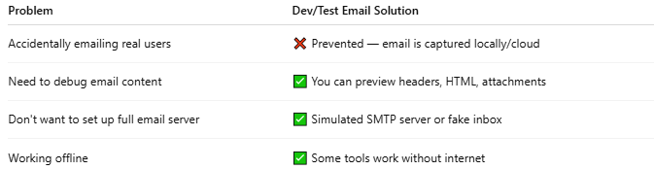

Problem | Dev/Test Email Solution
Accidentally emailing real users | ❌ Prevented — email is captured locally/cloud
Need to debug email content | ✅ You can preview headers, HTML, attachments
Don't want to set up full email server | ✅ Simulated SMTP server or fake inbox
Working offline | ✅ Some tools work without internet

🧰 Common Dev/Test Email Tools
# Source: AI Source: Provided by: [Data Path: Persons Table -> ID Column: 1, Name_En Column: Motasem Essam] -> From: [ChatGPT] on [1/21/2026]
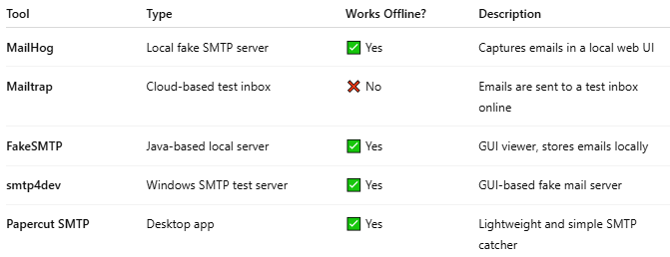

Tool | Type | Works Offline? | Description
MailHog | Local fake SMTP server | ✅ Yes | Captures emails in a local web UI
Mailtrap | Cloud-based test inbox | ❌ No | Emails are sent to a test inbox online
FakeSMTP | Java-based local server | ✅ Yes | GUI viewer, stores emails locally
smtp4dev | Windows SMTP test server | ✅ Yes | GUI-based fake mail server
Papercut SMTP | Desktop app | ✅ Yes | Lightweight and simple SMTP catcher

🧪 Typical Workflow for Dev Email
# Source: AI Source: Provided by: [Data Path: Persons Table -> ID Column: 1, Name_En Column: Motasem Essam] -> From: [ChatGPT] on [1/21/2026]
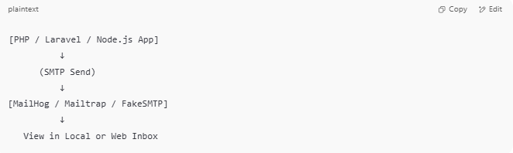

[PHP / Laravel / Node.js App]
↓
(SMTP Send)
↓
[MailHog / Mailtrap / FakeSMTP]
↓
View in Local or Web Inbox

✅ Example Use Case
# Source: AI Source: Provided by: [Data Path: Persons Table -> ID Column: 1, Name_En Column: Motasem Essam] -> From: [ChatGPT] on [1/21/2026]
Imagine you’re building a "Forgot Password" feature.
In production, this email would go to the user.
In development, using MailHog or Mailtrap:
- You still send the email via PHPMailer
- But the email is captured locally (not sent)
- You can check the reset link, design, and content safely

📌 Summary
# Source: AI Source: Provided by: [Data Path: Persons Table -> ID Column: 1, Name_En Column: Motasem Essam] -> From: [ChatGPT] on [1/21/2026]
Dev/Test Email tools simulate real email delivery so developers can test email features without spamming real users or needing full mail server setup.

